**Assignment 1**

*Finding the XPath of the given component*

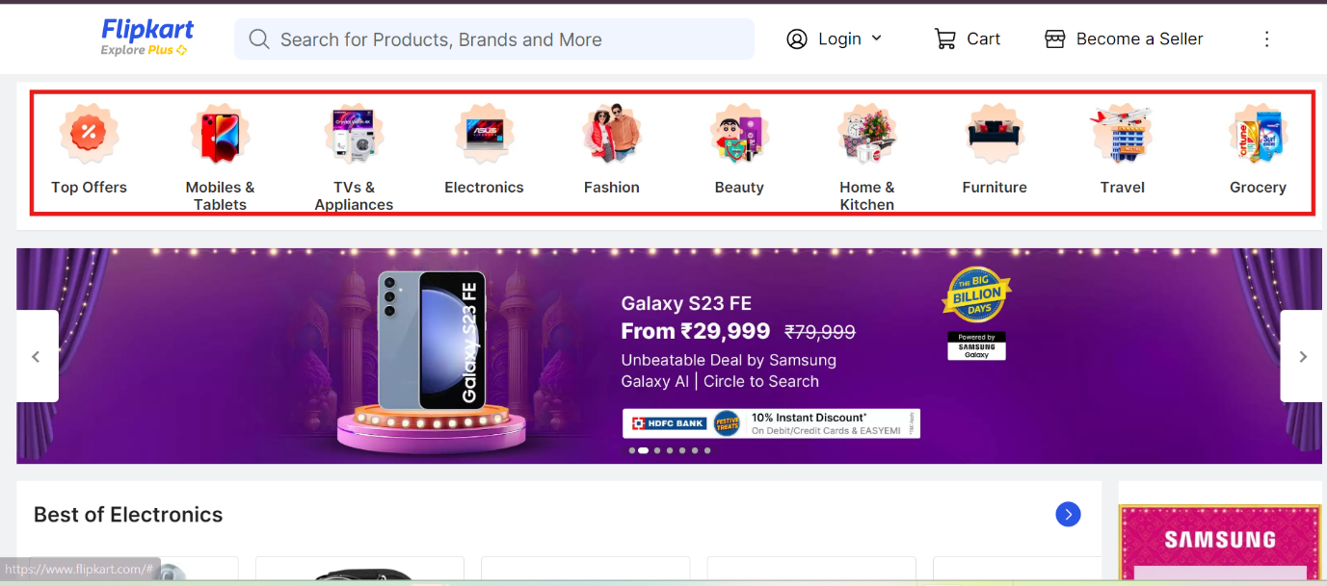

1. Relative XPath (using starts with)

//*[starts-with(@class,'_3s')]

1. Relative XPath (using contains)

//*[contains(@class,'3s')]